PUNE INSTITUTE OF COMPUTER TECHNOLOGY

(DHANKAWADI, PUNE-43)



MINI PROJECT REPORT ON

“Book Review And Management System”

SUBMITTED BY

Shraddha Pandey (3065)

Sudhanshu Pandey (3065)

Rohit Tawre (3065)

Jairaj Patil (3075)

(Third Year Information Technology)

UNDER THE GUIDANCE OF

Prof.J. K. Kamble

Submitted To

**Pune Institute of Computer Technology**

**For Academic Year 2017-18**

**ABSTRACT**

The mini-project of ‘Book Review And Management System’ serves the purpose of reading book summary and rating it, view critics ratings and also buying the favourite book with just few clicks. The System also intends to provide global readers to help the reading community by giving their valuable ratings to book .

**ACKNOWLEDGEMENT**

We would like to express deep sense of gratitude towards the college and our Principal Dr. P.T. Kulkarni for allowing us the opportunity to work on and present this project report.

We would also like to extend our gratitude to Professor R.B. Murumkar, Professor S.A. Jakhete and Professor J.K. Kamble, for the able guidance and continuous support they provided which helped to successfully compile and prepare our project and report.

We are also thankful to all the staff members of the Department of Information Technology of Pune Institute of Computer Technology for their valuable time, support and suggestions.

We would like to thank all those who have directly or indirectly helped us for the completion of the work of this project.

**Table of Contents**

|  |  |
| --- | --- |
| **TITLE** | **PAGE NO.** |
| **Introduction**  **Purpose**  **Scope**  **Definition**  **Developer’s Responsibilities: An Overview** | **6** |
| **General Description**  **Product Function Perspective**  **User Characteristics**  **General Constraints**  **Assumptions and Dependencies** | **7** |
| **Specific Requirements**  **Inputs and Outputs**  **Functional Requirements**  **Functional Interface Requirements**  **Performance Constraints** | **8** |
| **System Design**  **ER Model**  **Table Definition**  **Use Case Diagram**  **Errors/Messages and Alert Design** | **10** |
| **System Implementation  Hardware and Software Used**  **Tools Used**  **Future Work or Extension** | **17** |
| **Conclusion and References** | **18** |

# 1. INTRODUCTION

**1.1 Purpose**

The topic of the project is Book Review and Management System and in this project we provide books to user so that they can buy it. The site helps reader to help other readers to know about the book. The site contains the valuable ratings given by critics. Even if the buyer hasn’t bought the book from our store he can rate it and help the reading community to grow.The site also provides the facility of COD mode payment options across the city.

# 1.2 Scope

1. The site is used for buying book and rating it.
2. Site matches user with the right book.
3. Admin has the control on all the activities, with respect to adding ,deleting, modifying database information.
4. Each User has its own login. Admin can modify the tables.
5. Buyer can buy the book according to its favourite genre and can rate it even if he hasn’t bought the book from our store.

# 1.3 Definitions, Acronym, and Abbreviations

1. ERD(Entity Relationship Diagram): Shows the relationships of entity set, stored in a database. It illustrates the logical structure of the database.
2. UML Use Case Diagram: Are usually referred to as behavior diagrams used to describe set of actions(use cases) that some system should or can perform in collaboration with one or more external users(actors) of the system.
3. Table Schema: This schema is contained in each database. Each information schema view contains metadata for all data objects stored in that database.

**1.4 Developers’ Responsibilities: An Overview**

1. Market analysis for establishing a detailed program specifications according to user requirements.
2. Clarifying what actions the program is intended to perform.
3. Breaking down program specifications into its simplest elements and translating this logic into a programming language.
4. Devising possible solutions to anticipated problems.
5. Combining all the elements of the program design and testing it.
6. Updating, Modifying and developing the software for different applications

**2. GENERAL DESCRIPTION**

**2.1 Product Function Perspective**

This service system provides a platform for users to buy his favourite book. The user can also view his previous orders and also modify his cart . He can also rate any book after login and can see other users and critics ratings.  
An Admin login gives the owner of the product a brief insight of the order statistics. It is a one stop shop for all types of books.

**2.2 User Characteristics**

This site provides the usage characteristics like the total money spent by the user. Along with this the user can view his current cart and completed orders. The admin gets to see the best sellers and worst sellers of his store.   
The User gets a chance to view ManBook nominated books and also the bestsellers of the current time.

**2.3 General Constraints**

1. Number of books are limited so if number of requests for a particular book exceeds available book, user has to wait till stocks gets updated.
2. Time conflict may occur.

**2.4 Assumptions and Dependencies**

1. In case of any conflict regarding timings, the customer and the owner will handle the issue with mutual consent.
2. Truthful delivery of order by the owner .

# 3. SPECIFIC REQUIREMENTS

# **3.1 Inputs and Outputs**

1. Registration customer has a user data .
2. User gets a chance to buy his favourite book.
3. User gets a chance to view other users ratings.
4. Confirmation of a book purchased.
5. Verification of order.

**3.2 Functional Requirements**

1. Login:  
   Precondition: Sign Up with required details   
   Postcondition: User Account is successfully created
2. Rating Book:  
   Precondition : Customer must be logged in and must select a book.  
   Postcondition : His valuable rating helps in updating the user ratings value.
3. Buying book:  
   Precondition: Customer must be logged in to fill up the details to modify.  
   The Customer has to choose the book and then add to cart to proceed to checkout.  
   Postcondition: Order is successfully placed and order table gets updated.

**3.3 Functional Interface Requirements**

1. Register button has been provided on the homepage to sign up.
2. Navigation bar has been provided to navigate through the various pages.
3. Cart is provided to every customer
4. Admin dashboard helps him to view monthly sales.
5. User gets the confirmation message after buying the book.

**3.4 Performance Constraints**

The Book Review and Management System can be accessed on PCs with Internet connection. The performance with respect to speed depends upon the strength/presence of a good Internet connection. The system cannot be accessed through a domain URL, since it is hosted on localhost.

# 4. SYSTEM DESIGN

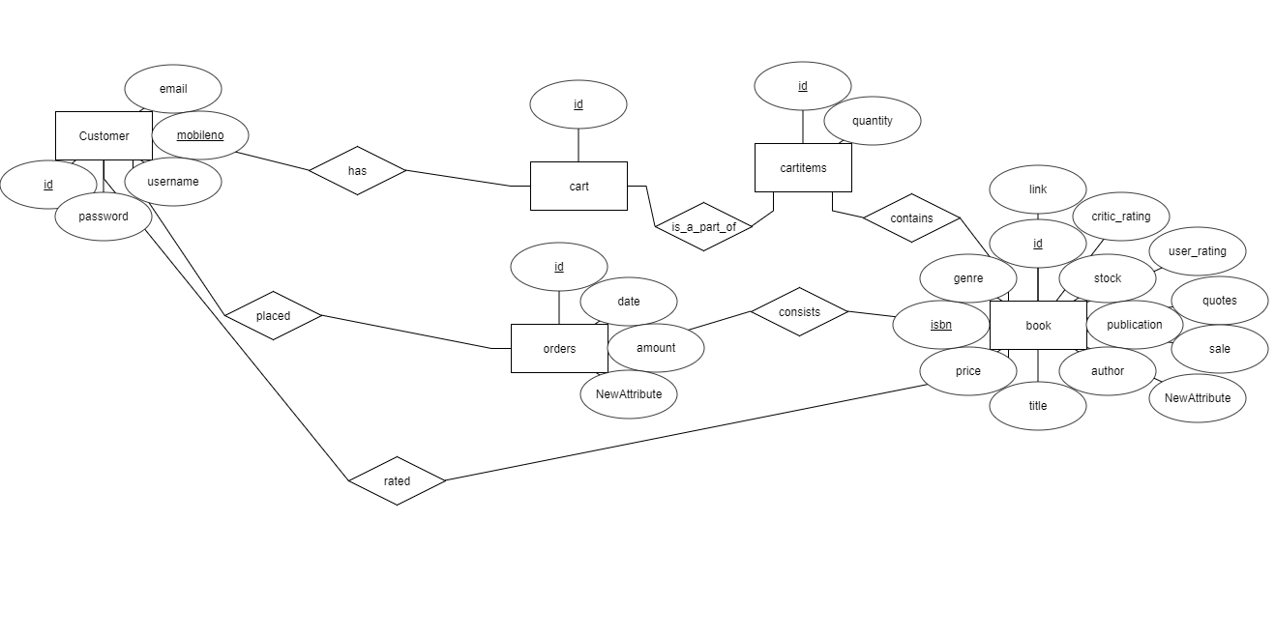**4.1 ER Diagram**

# 4.2 Table Definition

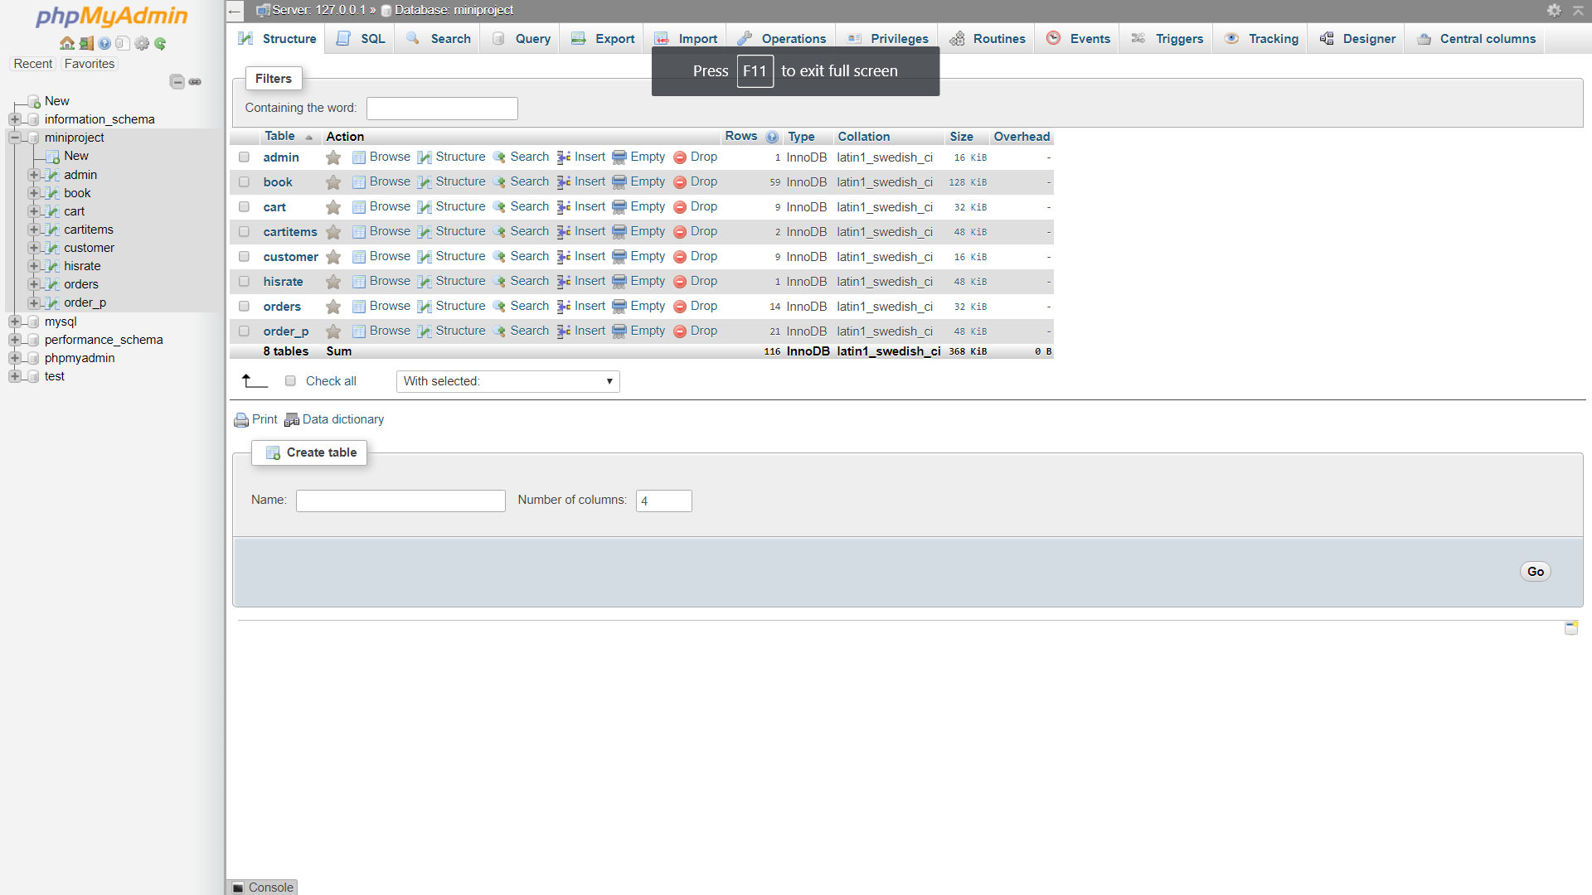4.3 Use Case Diagram

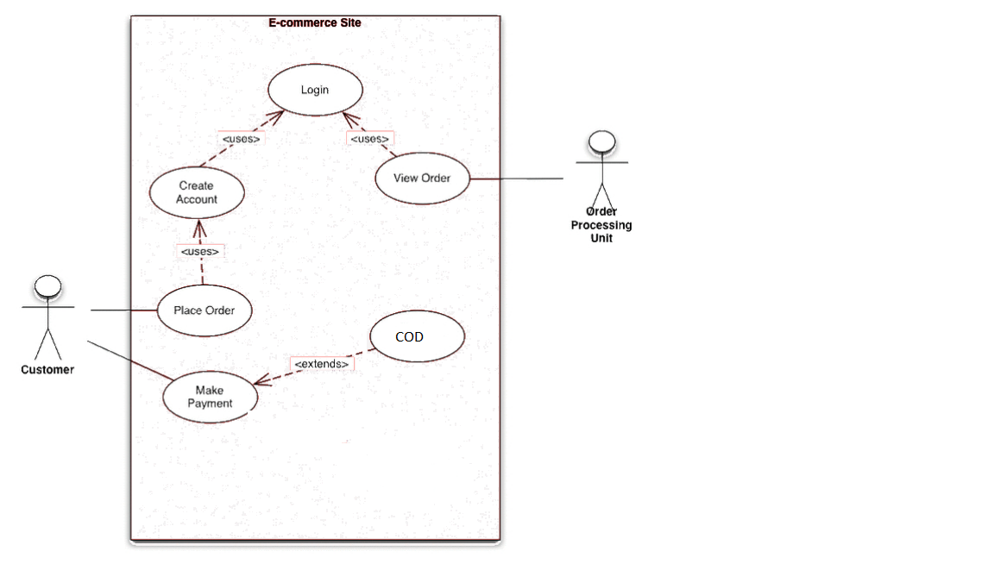

**4.4 Error Messages/Alert Design**

1. An alert box is displayed on successful login/logout and creation of account.
2. If a user account already exists, an alert box notifies the user about the same.
3. Acknowledgement of a successfully placed order is done via an alert box.
4. Admin gets an alert box notification when he adds, modifies,deletes the book.

**Snapshots of website and tables**

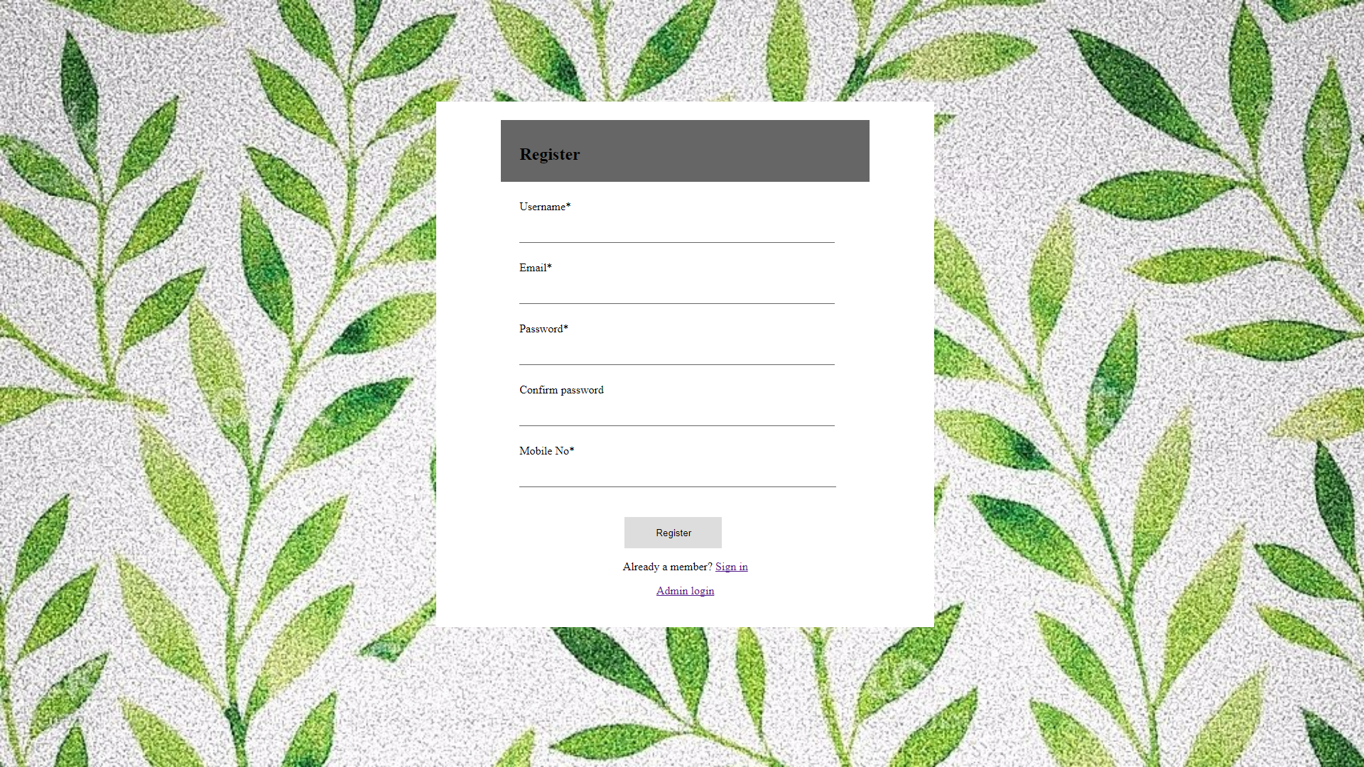

Home Page

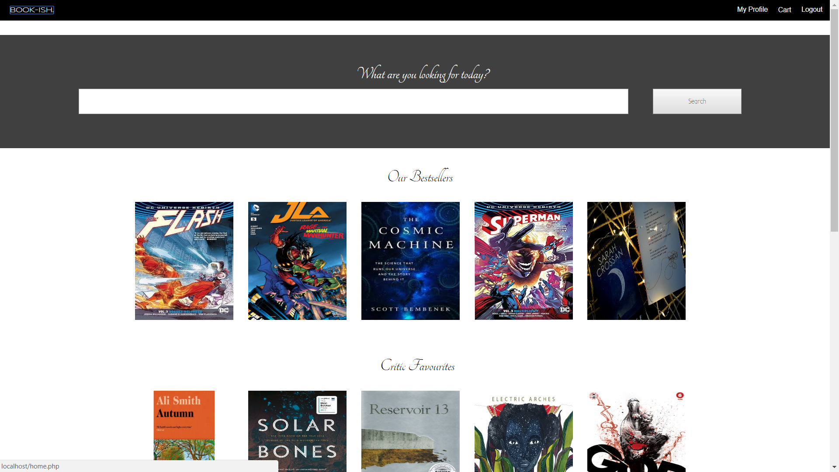

Product



Product Price

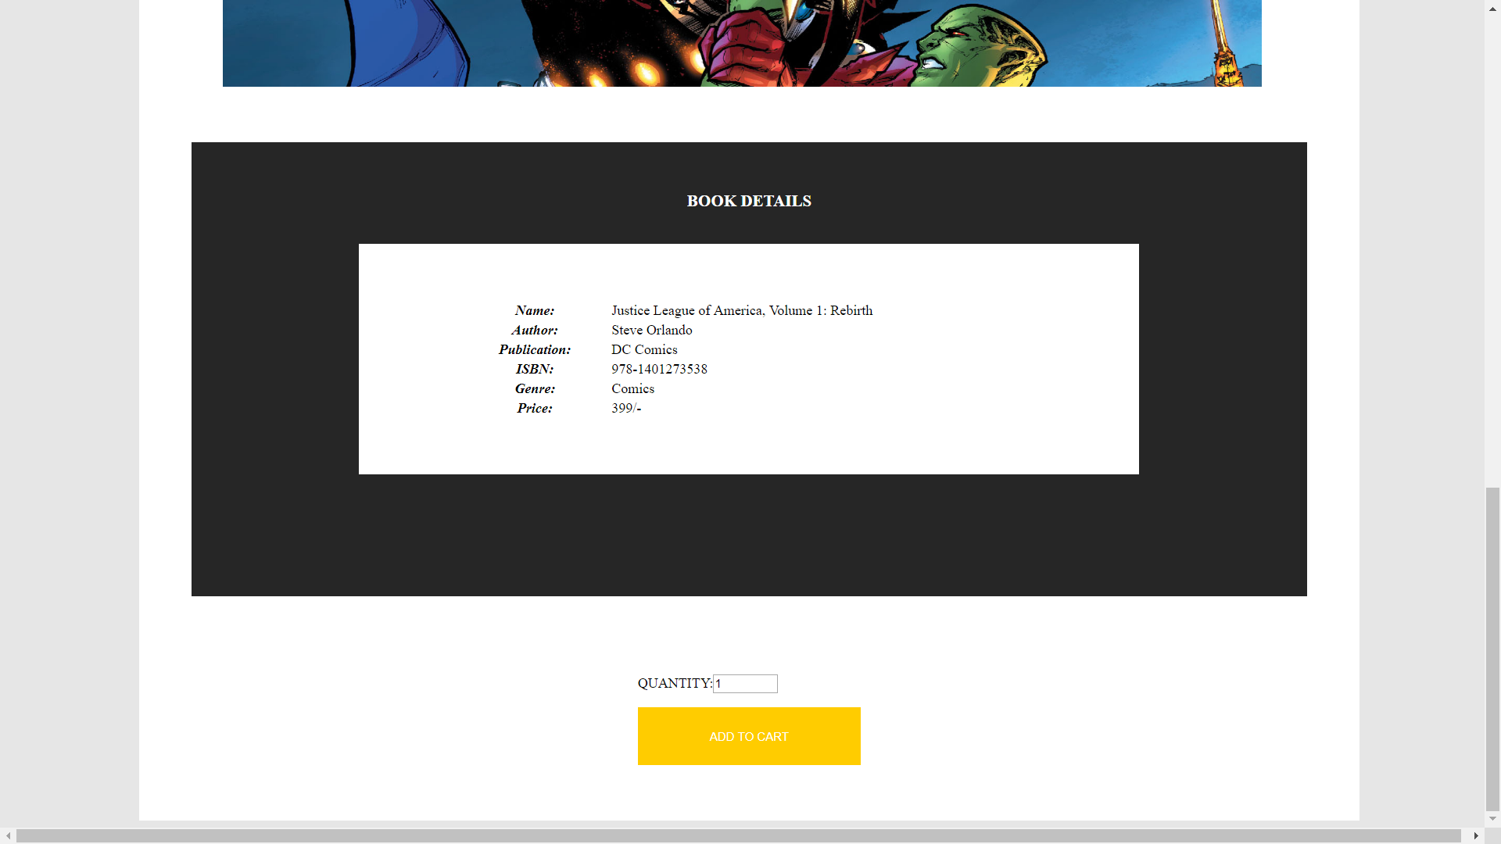

**Cart :**

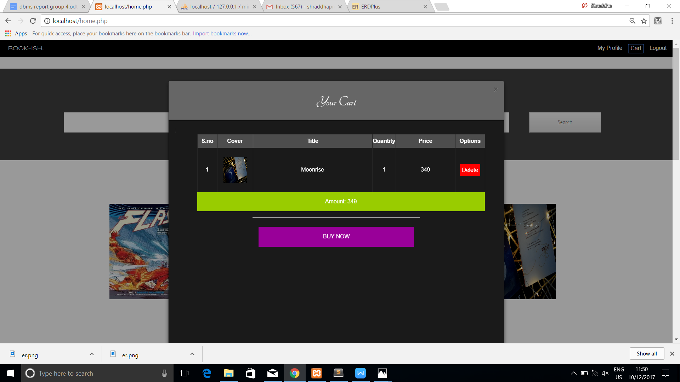

**Cart Summary**

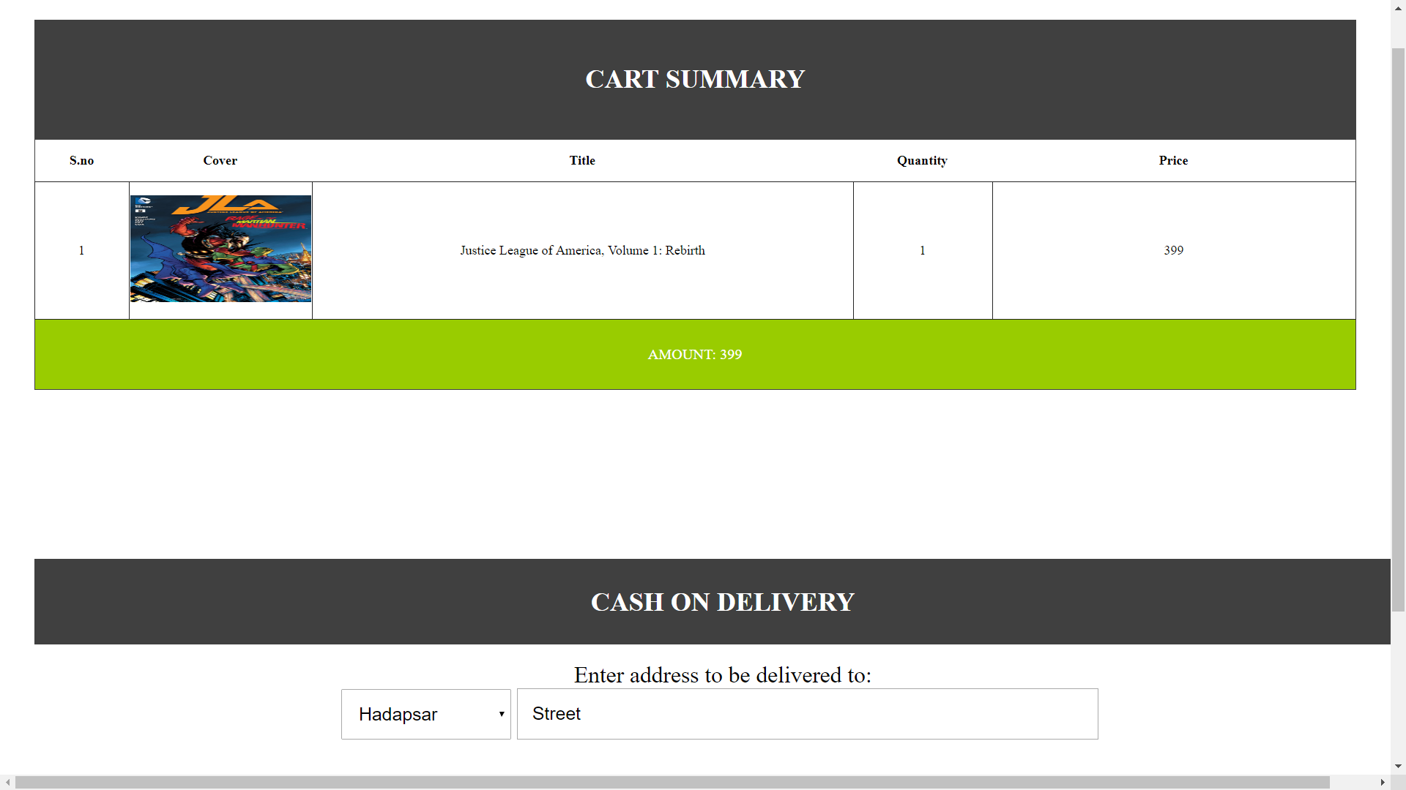

**Order Confirmation**



**User Profile**

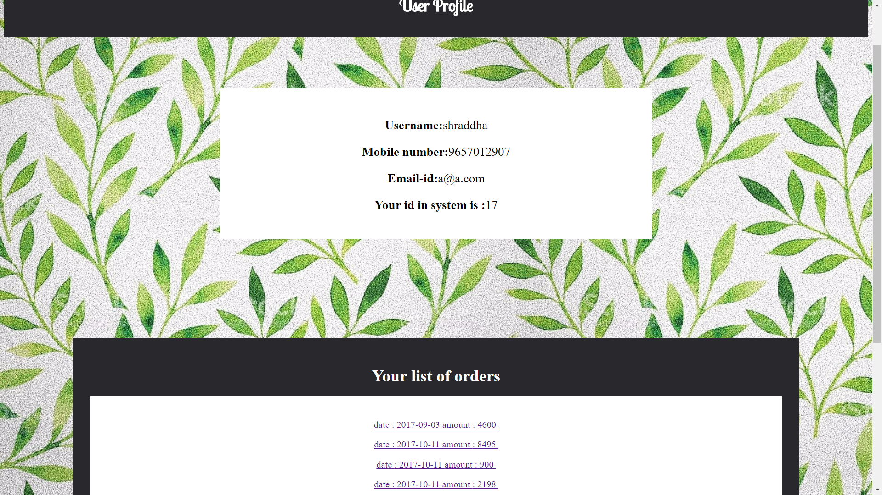

Search Results

# 

Admin Login

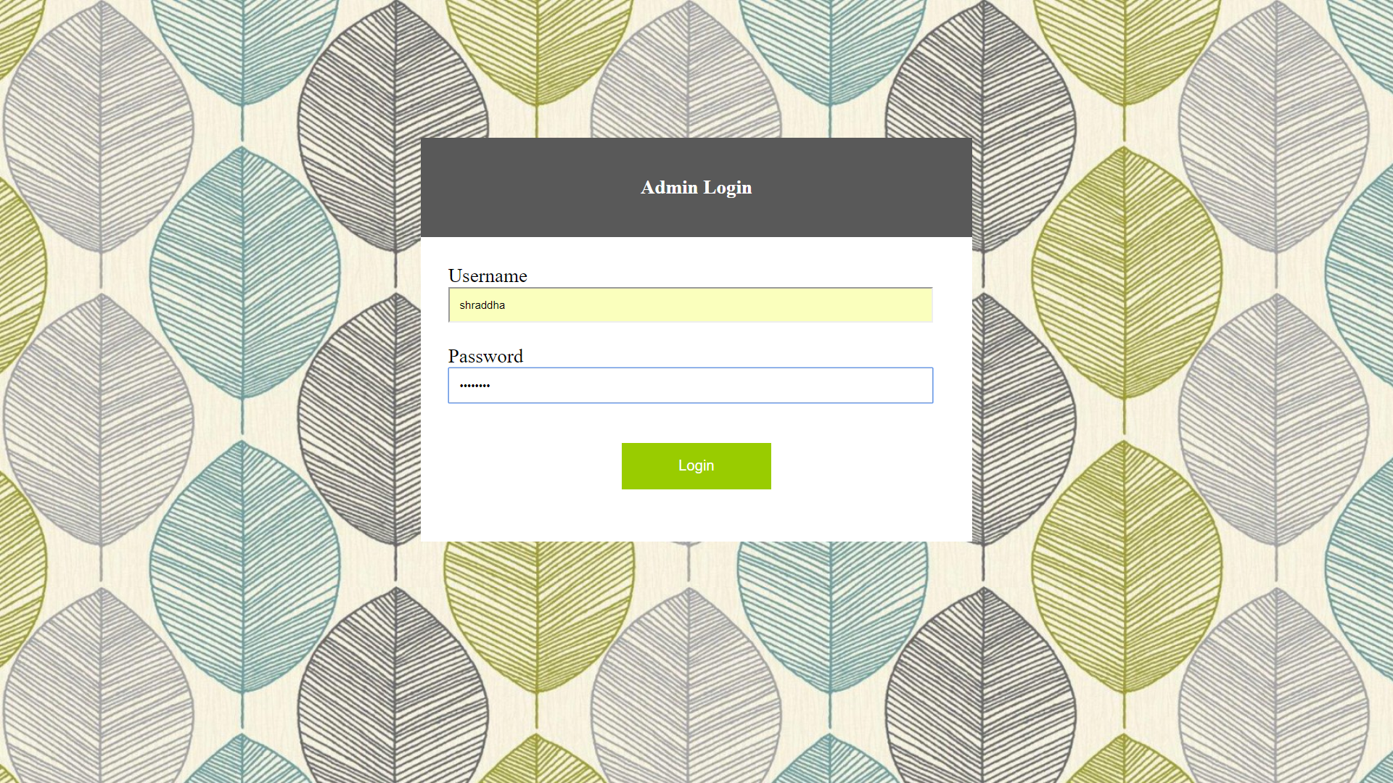

Admin Dashboard

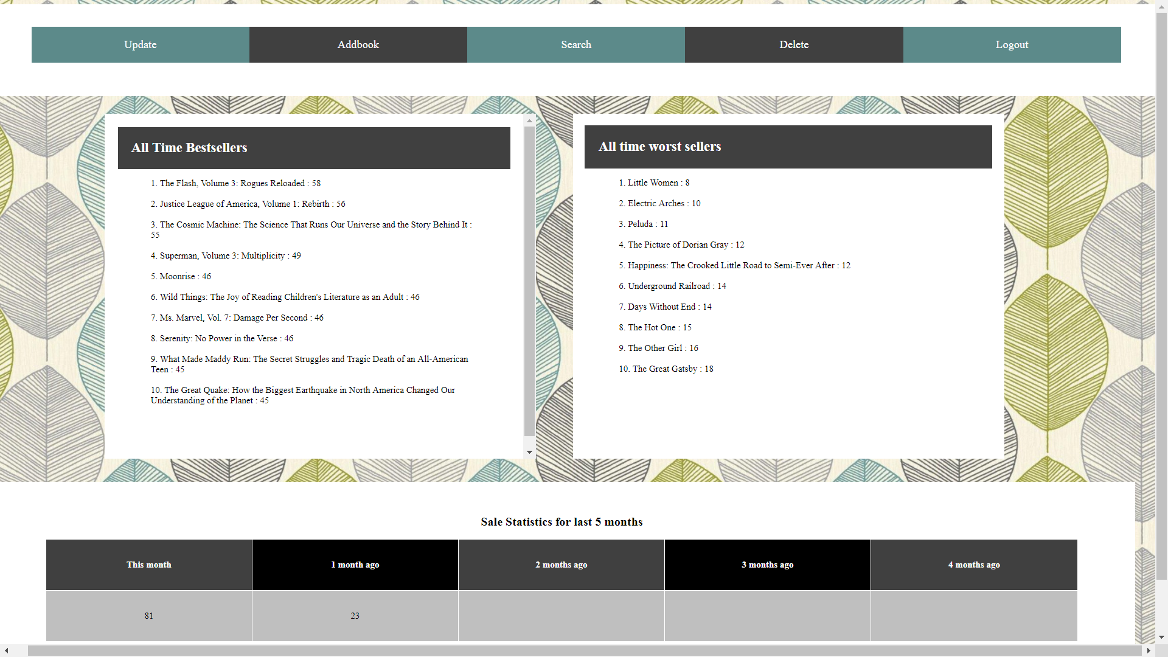

Admin Rights : Delete , Add, Modify Books

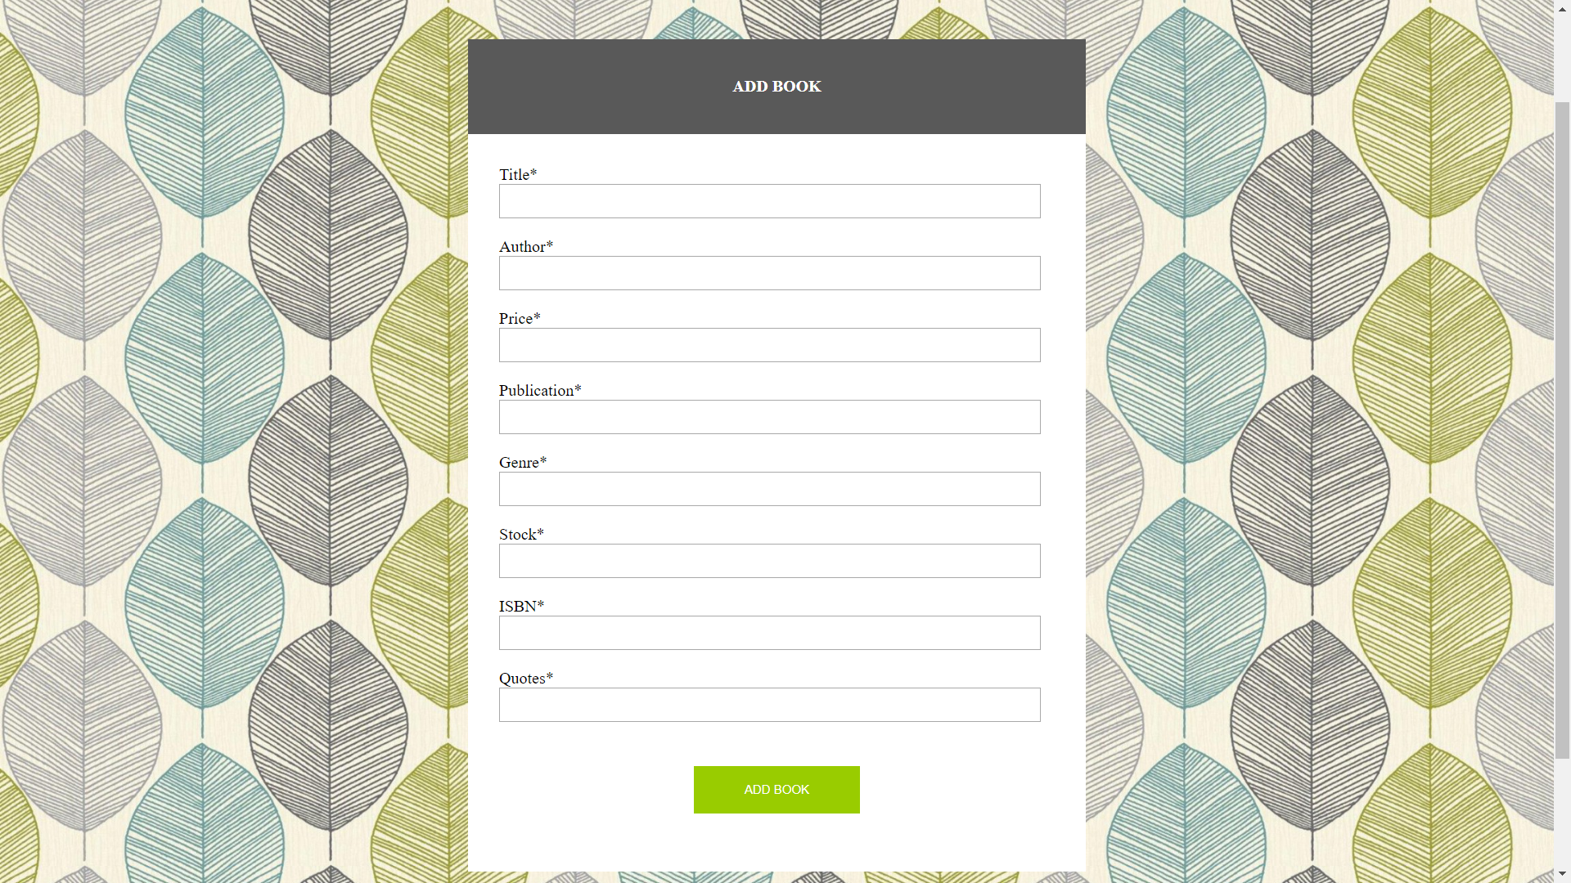

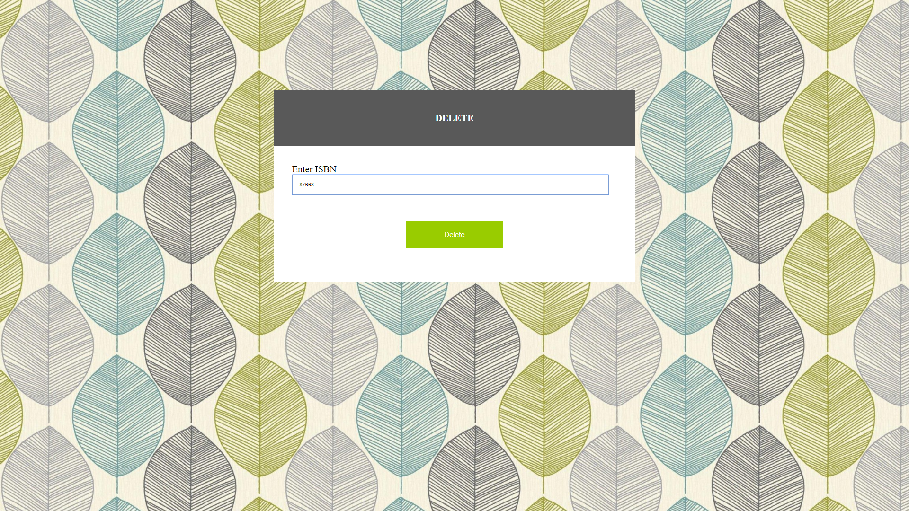

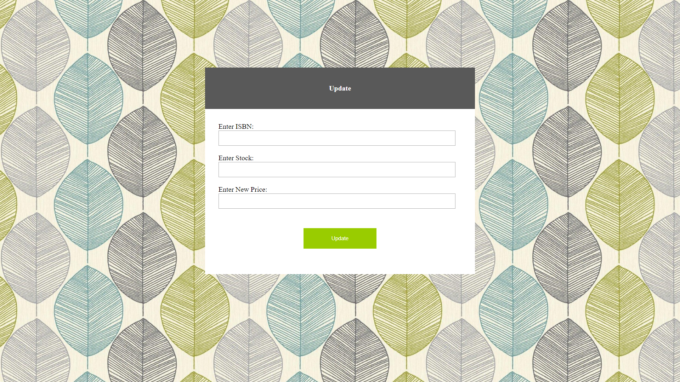

Admin Search

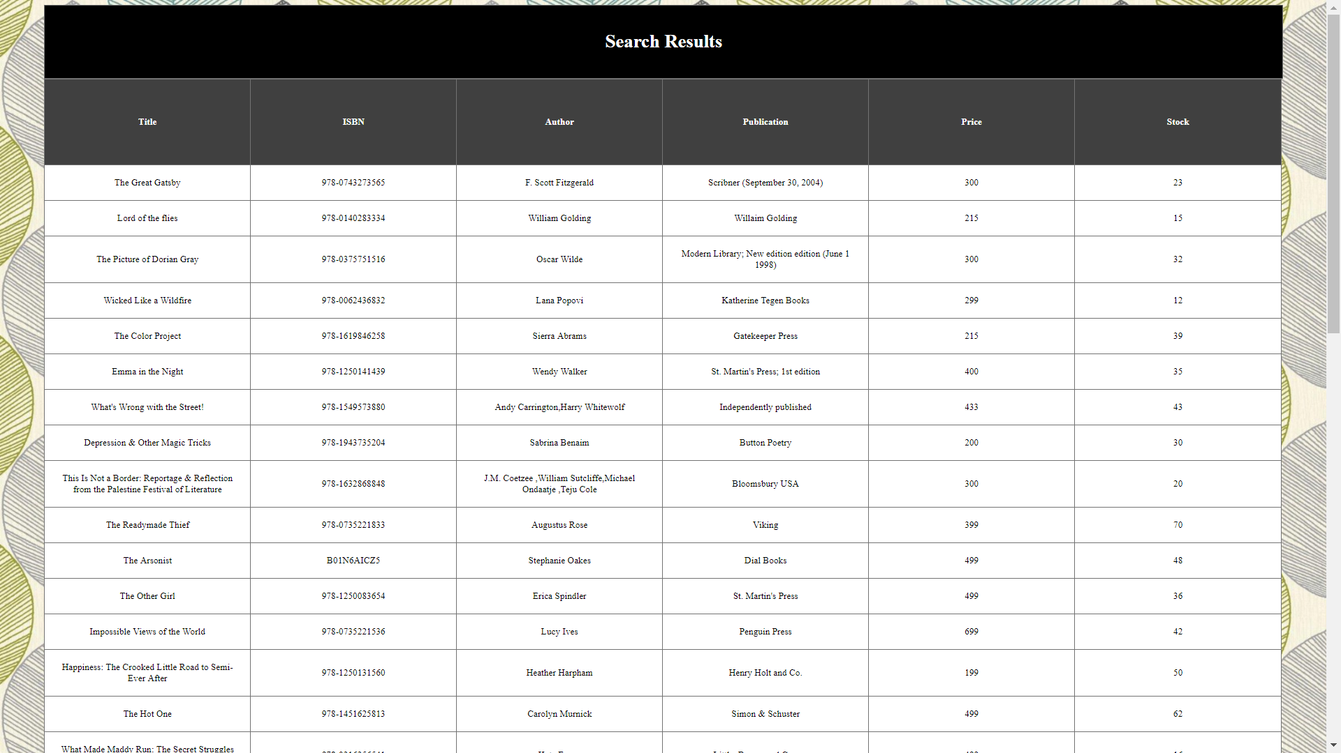

Tables

Structure : Books, Customer, Cart,Orders

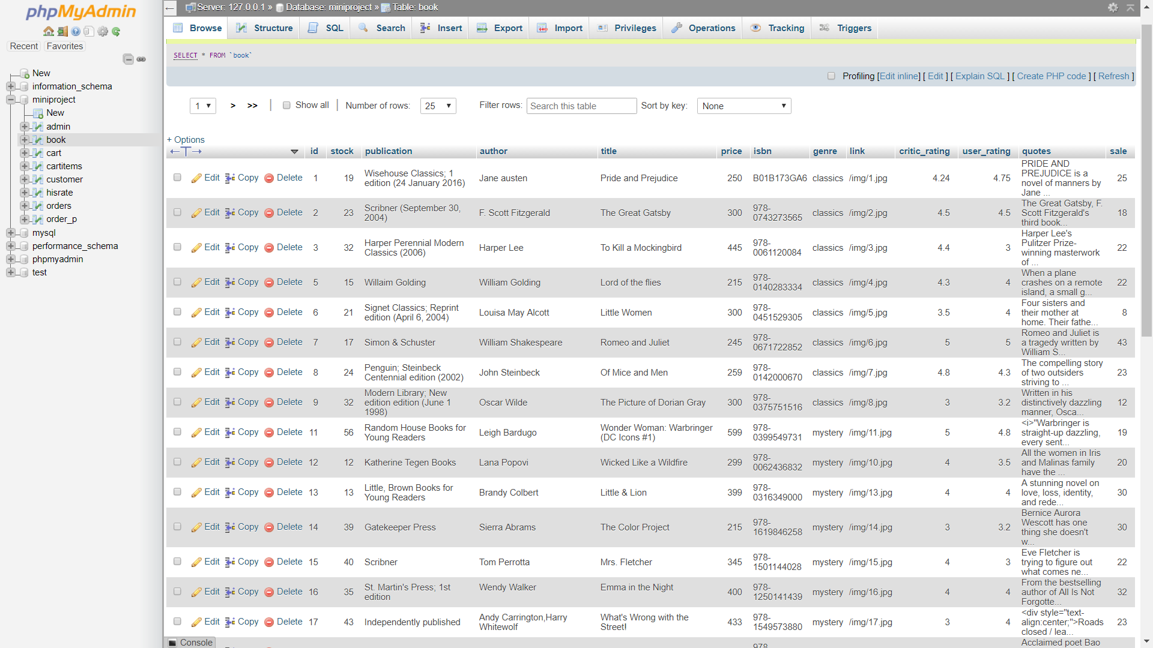

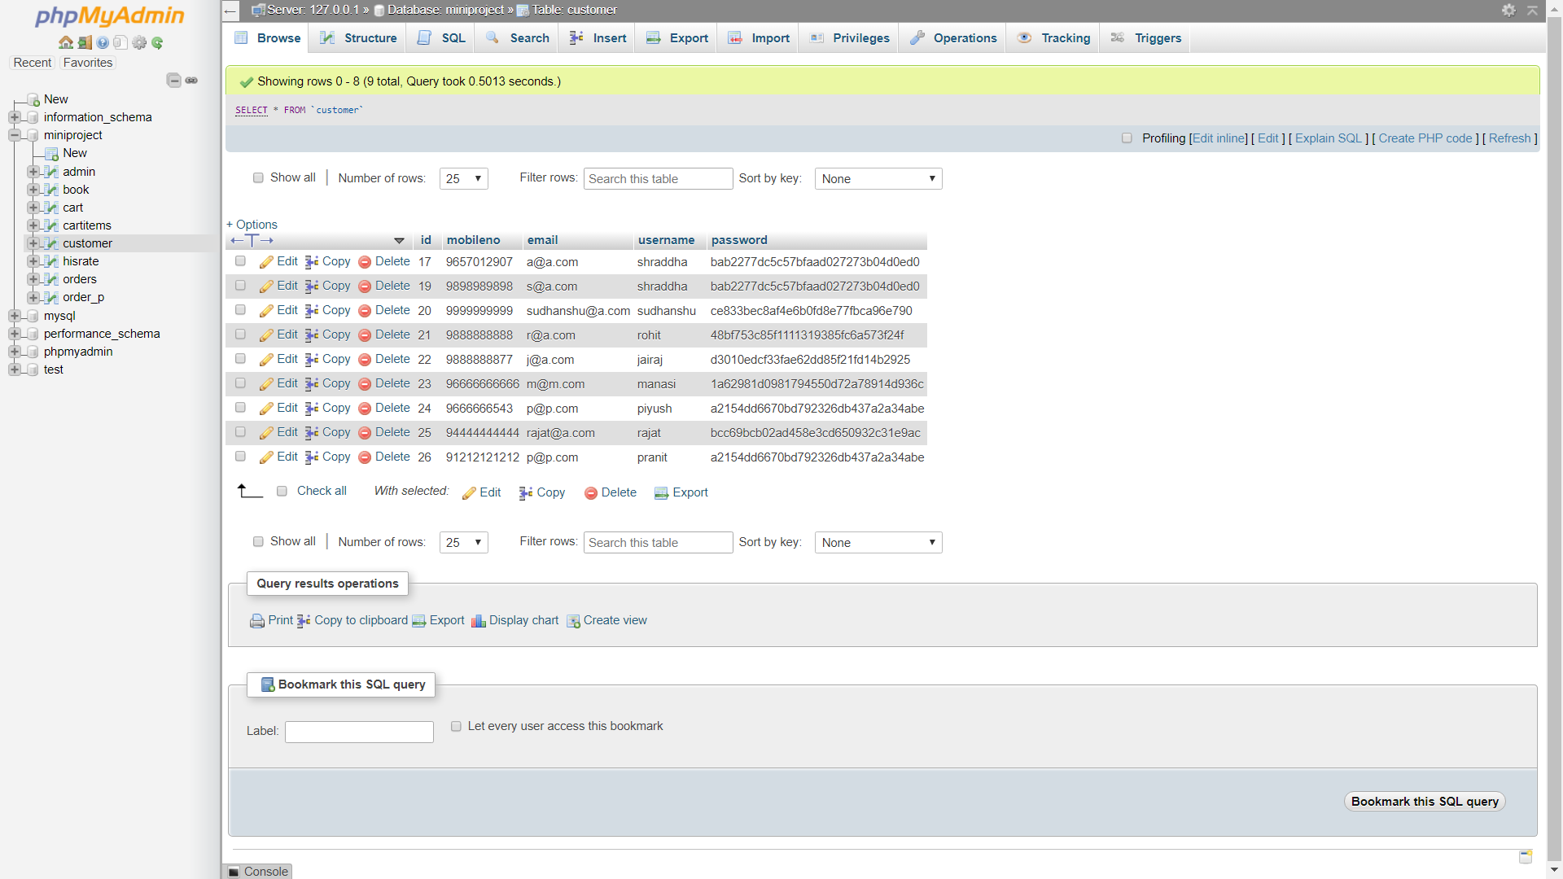

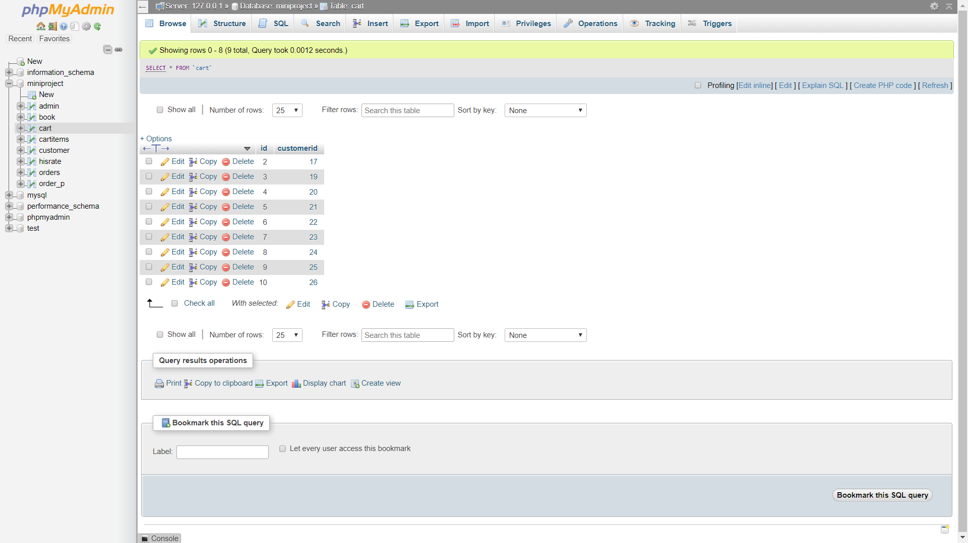

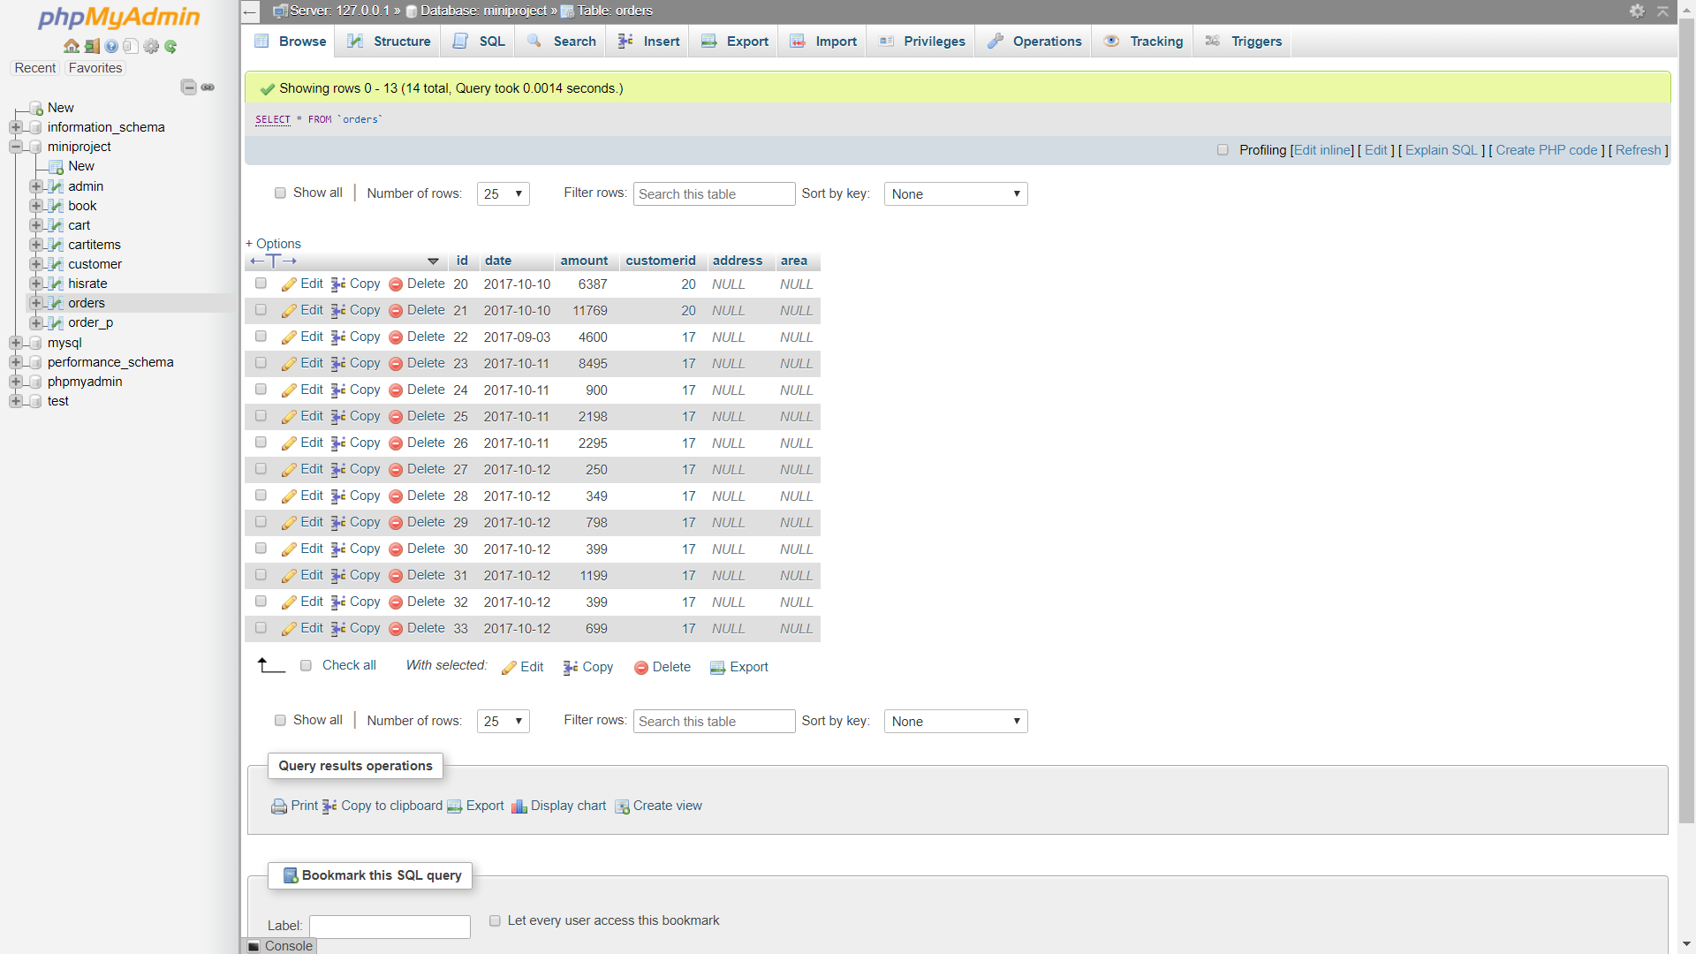

**5. SYSTEM IMPLEMENTATION**

# **5.1 Hardware and Software used:**

1. Hardware System with minimum requirements as follows:

Pentium IV processor

Color monitor

1. Software used:

Linux OS: Ubuntu

WSGI and Jinja2 Engine

**5.2 Tools used**

1. HTML, CSS, JavaScript
2. MySQL
3. Flask: A python Framework

# **5.3 Future work/Extension**

The Book Review and Management System can be integrated to work with the existing service web portals. In future, the scope of the system can be helping the global reading community.More books and more payment options can be added.

# **6. CONCLUSION**

The Project is developed through well thought flow and architectural design concepts, while integrating different software functionalities via using multiple programming languages to build an highly functional Service System.

The Front End of the web application is developed using HTML, CSS and JavaScript. The Relational Database is created using MySQL. Integrating both the ends with Jinja2 template engine also known as Flask, the programming ecosystem thus created is fit for real world application and is ready to be deployed to be directly used by businesses.

**7. REFERENCES**

1. [www.stackoverflow.com](http://www.stackoverflow.com/)
2. [www.geeksforgeeks.org](http://www.geeksforgeeks.org/)
3. [www.tutorialspoint.com](http://www.tutorialspoint.com/)
4. [www.searchsqlserver.techtarget.com](http://www.searchsqlserver.techtarget.com/)